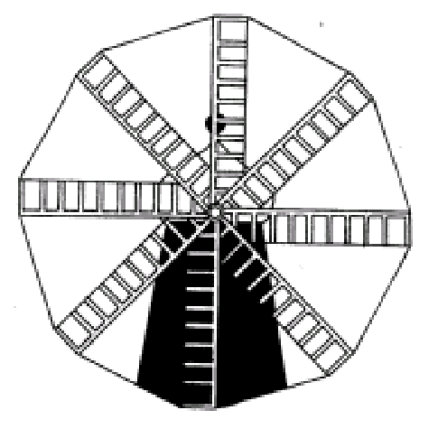

**Heckington St Andrews Primary School**

Early Years Foundation Stage

2023/2024

Parent Questionnaire

Child’s Name: ________________________________

Date of Birth: ________________________________

**Please provide the best number for us to call to speak about your child in the coming weeks:**

Name: _____________________________

Contact Number:________________________

**Please complete this questionnaire to help me to support your child in their transition to full time education.**

1. Who lives in your house?

________________________________________________________

________________________________________________________

2. Does your child have any siblings? How old are they?

________________________________________________________

________________________________________________________

3. Do you have any pets?

________________________________________________________

________________________________________________________

Ask your child to draw a picture of people that are important to them.

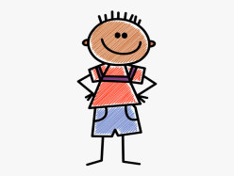

4. Please tell me about your child's favourite things:

Toys:

________________________________________________________

________________________________________________________

Stories:

________________________________________________________

________________________________________________________

Songs:

________________________________________________________

________________________________________________________

Games:

________________________________________________________

________________________________________________________

Things to do at the weekend:

________________________________________________________

________________________________________________________

5. Do you celebrate any religious or cultural events?

________________________________________________________

________________________________________________________

6. Is your child toilet trained? Are they independent when using the toilet?

________________________________________________________

________________________________________________________

7. Does your child have any medical, health or Special Educational Needs?

________________________________________________________

________________________________________________________

________________________________________________________

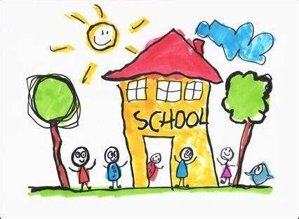

8. How well does your child speak? Can other people apart from you understand him/her? Does your child speak any other languages alongside English?

________________________________________________________

________________________________________________________

9. What makes your child sad/upset/angry? What helps to comfort them?

________________________________________________________

________________________________________________________

10. Does your child like to mix with other children and adults, other than immediate family? Or do they prefer to play alone?

________________________________________________________

________________________________________________________

11. What is your child most looking forward to about starting school?

________________________________________________________

________________________________________________________

12. Do you have any worries or concerns about your child starting school?

________________________________________________________

________________________________________________________

________________________________________________________

13. Additional information I may find useful to know about your child. e.g. family situation (parents separated, if a second report is required), family medical conditions (for example, mother diagnosed with dyslexia).

________________________________________________________

________________________________________________________

________________________________________________________

Thank you for your co-operation. I am very much looking forward to working with both you and your child over the coming year.

**Mrs Bontoft**