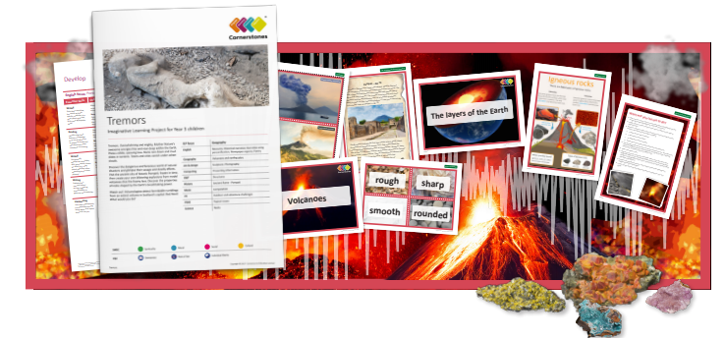
What happens when the Earth shakes? In this project, we’ll find out about the dangerous world of natural disasters and their deadly effects. This half term we’ll gather rock samples, find out about different types of rocks and sort them according to their properties. By carrying out research, we’ll investigate the Earth’s layers and the location of volcanoes, discovering what causes them to erupt. We’ll write newspaper articles inspired by our work on volcanoes. Working as archaeologists, we’ll locate Mount Vesuvius on a map and find out what it was like to live in Pompeii during the eruption. We’ll use different modelling materials to create a volcano – watch out, it’s going to blow! At the end of the ILP, we’ll create digital presentations, so you can see all of the exciting things we’ve learned about.
- English – Recounts – Newspapers and recount.
- Geography- Volcanoes and earthquakes..
- Computing -Presenting information
- D&T- Structures and Pneumatics.
- History- Ancient Rome – Pompeii
- Music- Composition
- PE- Outdoor and dance.
- PSHE-Being me in my world
- Science –Rocks.
Help your child prepare for their project Earthquakes and volcanoes are fascinating forces of nature. Why not research famous earthquakes and volcanic eruptions, and plot the locations on a map? You could also hunt for rocks in your garden and sort them into groups by their appearance. Alternatively, you could build small structures from recycled materials and test them to see if they could withstand an earthquake!

