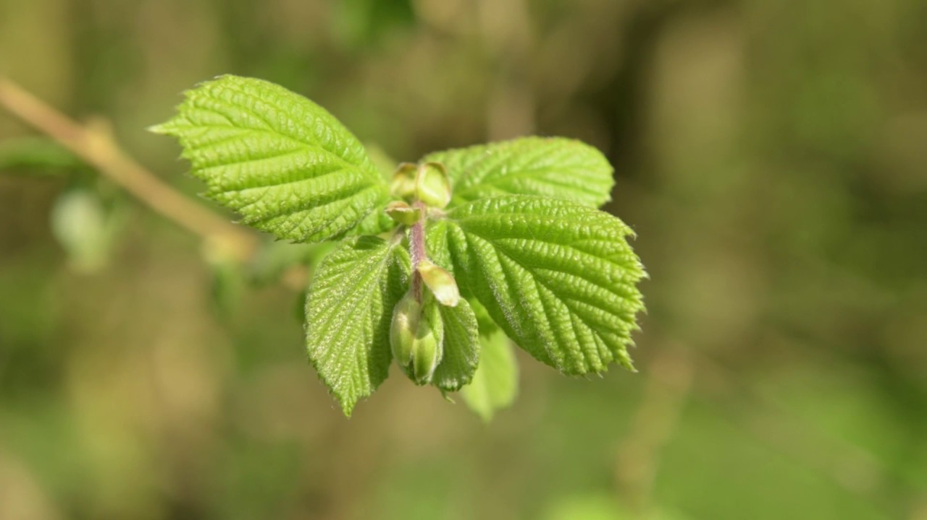
Welcome to

Hazel Class

Routines
At the beginning of the school day, the first bell signals the children to come to line up and say goodbye. You are welcome to stand at the back of the playground to wave them off ☺. On the second bell, the class goes into school.
If you have a quick message, you can catch us on the playground in the morning before the bell goes. Otherwise, please make an appointment at the office for a longer chat.
Mr Allen will have some responsibility for delivering lessons in Hazel class– usually Monday and Thursday afternoons.

Expectations
By Year six children should be responsible for their own learning. We expect them to give their best at all times and engage with all we do so that they can get the very best out of every opportunity presented to them. The school behaviour policy echoes our five core values (respect, resilience, relationships, reverence and responsibility) with a heavy emphasis on respectful behaviour.
The simple behaviour policy ensures that there is a consistent approach to encouraging good behaviour and redirecting it when necessary.

Curriculum
You will receive a letter telling you all about the topic at the beginning of each half term. This terms topic is World War Two.

Snacks/water
Children in Key Stage two do not receive free fruit/veg for a morning snack. Therefore, we ask you to send an extra fruit snack in their bag. This must be fruit/veg, they will not be allowed to eat crisps, biscuits or chocolate at break time.
Children can access their water bottles at all times during the day, apart from during the lesson input. If your child needs a water bottle, they can be purchased from the office. Please name it. We would appreciate it if water bottles weren’t screw tops as we have fewer spillages with ‘sports cap’ bottles and the bottles with flick up straws. Children can only drink water in the classroom; they are not allowed to drink juice.

Homework
EVERY WEEK
- Practise x tables (every day) so they are INSTANT! There will be tables tests in terms 1, 3 and 5.
- Spellings are usually linked somehow, either by meaning or spelling rules. Spelling lists are designed to increase vocabulary as well as help with spelling. It is important to think about spellings, to get them firmly into the long term memory rather than just learning them for a test. There will be spelling tests in terms 2,4,and 6.
- Find a news report. Write it in your own words. Find where it happened on a map of the world. For Fridays (odd term numbers only)
- Reading book: aim for every night for about ½ an hour. Please sign your child’s reading record each week.
- World expert (30 minutes per week)
- Occasionally one additional piece of work – task set in homework book.

Reading
Please encourage reading of any kind. Friday news reports are a good way to look at different genres.
Reading for enjoyment is important. We change books as we are ready and are not tied to schemes. Take a risk when choosing a book. If you don’t like it you can always change it. You might discover a new favourite author.

PE
Kit needs to be in every day. Usually we do PE on Monday and Tuesday but we don’t like to be too regimented.

Assessment
The children are continually assessed. At three checkpoints in the year (Oct/Nov, Feb and June) we assess the children, with the third checkpoint being NFER tests (special booklets) that we use to support our ongoing, regular teacher assessments. We also use learning journeys, to help assess the children’s continual progress, this is a document the children will use themselves.

Please don’t hesitate to ask if you have any concerns or queries.

Here’s looking forward to a brilliant year in Hazel Class.

The Hazel Team,
Mr Fuller, Mr Allen, Mrs Lafferty

